Sentiment Analysis of Amazon Grocery & Gourmet Food Reviews
  - Using Apache Spark on Google Cloud Platform
CAP 4786 – Topics in Big Data
Report by: Jaydon Debus and Philipp Kouterguine

Table of Contents
Sentiment Analysis of Amazon Grocery & Gourmet Food Reviews 1
1. Introduction 3
2. Literature Review 3
2.1 The Need for Distributed Processing 3
2.2 Model Selection and the Case for Simplicity 3
2.3 Simplifying the Problem: Binary Classification 4
3. Dataset & Data Preprocessing 4
3.1 Dataset Description 4
3.2 Data Acquisition and Streaming 4
3.3 Subset Sampling Strategy 4
3.4 Preprocessing and Labeling 5
4. Methodology 5
4.1 Spark ML Pipeline 5
4.2 Baseline Model 5
5. Distributed Architecture 5
6. Experimental Setup 5
6.1 Cloud Infrastructure 5
6.2 Software Environment 5
6.3 Pipeline Configuration 6
6.4 Evaluation Protocol 6
7. Results and Evaluation 6
7.1 Class Distribution 6
7.3 Logistic Regression Scalability Results 7
7.4 Naïve Bayes Baseline Results 7
7.5 Model Comparison 7
8. Discussion 7
9. Future Work 8
References 9

1. Introduction
Online platforms generate millions of customer reviews daily, yet manually analyzing this volume of feedback is infeasible for businesses. Traditional single-machine tools cannot efficiently process datasets at this scale. This project leverages Apache Spark on Google Cloud Platform to perform distributed sentiment analysis on Amazon Grocery & Gourmet Food reviews, allowing businesses to automatically classify customer sentiment as either Positive or Negative and extract actionable insights at scale. This report synthesizes the methodology and the findings of our distributed computing project, integrating insights from recent academic literature to validate our approach and contextualize our results. The Amazon Reviews 2023 dataset satisfies the six defining characteristics of Big Data, confirming that this project constitutes a genuine big data research workflow.
Volume: The Grocery and Gourmet Food category alone contains over 14.3 million reviews, a scale that renders single-machine processing infeasible and directly necessitates the use of a distributed framework such as Apache Spark on GCP Dataproc.
Velocity: Amazon receives customer reviews continuously in real time. Our pipeline demonstrates that even large subsets of this data (up to 250,000 reviews) can be processed and a model trained in under two minutes, reflecting the throughput capabilities required for near-real-time business intelligence.
Variety: The dataset combines structured fields (star ratings, product IDs, timestamps) with unstructured natural language text (review bodies), requiring both structured DataFrame operations and NLP preprocessing within the same pipeline.
Veracity: As with any user-generated content, the dataset contains noise in the form of ambiguous reviews, missing fields, and inconsistent language. Our preprocessing pipeline directly addresses this through text cleaning, null filtering, and the deliberate exclusion of 3-star reviews, which represent low-veracity sentiment signals.
Value: Customer sentiment is among the most actionable signals available to e-commerce businesses. The ability to automatically classify millions of reviews as positive or negative enables companies to identify product issues, monitor brand perception, and prioritize customer feedback at a scale no human team could achieve manually.
Variability: Consumer sentiment toward food products fluctuates with factors such as seasonal availability, supply chain disruptions, and changing tastes, meaning the sentiment distribution of reviews is not static and a deployed model would need periodic retraining to remain accurate.

2. Literature Review
Recent academic research reinforces the necessity of big data frameworks for processing large-scale e-commerce reviews and emphasizes the evolution of sentiment analysis techniques.

2.1 The Need for Distributed Processing
Aravindan et al. states that the exponential growth of Amazon food review data renders traditional Python-based methods inadequate [1]. Their study demonstrated that utilizing the Apache Spark data processing engine with MLlib significantly improves computational efficiency compared to non-distributed frameworks. This directly supports our decision to deploy PySpark on GCP Dataproc for our dataset of 14.3 million reviews. Crucially, their work confirms that Logistic Regression with TF-IDF features achieves over 87% accuracy on Amazon food review data — a strong baseline that our project builds upon.

2.2 Model Selection and the Case for Simplicity
Research indicates that while advanced deep learning models like RoBERTa excel at capturing complex semantics and sequential dependencies, traditional machine learning algorithms remain highly effective and computationally efficient for large datasets. Bao's comparative study found that while RoBERTa is superior for detecting nuanced sentiments, dictionary-based models like VADER are lightweight and fast, though they struggle with complex semantic correlation in longer texts [2]. This finding reinforces our choice of Logistic Regression: it is interpretable, scalable, and well-suited to demonstrating the core principles of distributed machine learning without unnecessary complexity.
Similarly, Aqlan's work on mining over 1.6 million tweets using Spark demonstrated the effectiveness of classical classifiers (SVM and Maximum Entropy) when handling large, unstructured datasets [3]. Usman's review of predictive modeling for Amazon ratings confirms that classical machine learning algorithms like Logistic Regression continue to serve as strong, reliable baselines, and that binary sentiment classification (Positive vs. Negative) remains the most widely validated and interpretable approach [4].

2.3 Simplifying the Problem: Binary Classification
A deliberate design decision in this project is the use of binary classification: categorizing reviews as either Positive (4-5 stars) or Negative (1-2 stars), with 3-star reviews excluded. This approach is consistent with the methodology used in Aravindan et al. [1], who similarly removed neutral reviews to produce a cleaner, more decisive training signal. The literature confirms that 3-star reviews frequently contain mixed sentiments that reduce model clarity without meaningfully improving business utility [2]. By focusing on clear positive and negative signals, our model achieves higher accuracy and delivers more actionable results.

3. Dataset & Data Preprocessing

3.1 Dataset Description
This project utilizes the Amazon Reviews 2023 dataset, specifically the Grocery and Gourmet Food category, accessed via the Hugging Face API. The full dataset comprises over 14.3 million customer reviews and contains a combination of structured fields including star ratings, product IDs, and timestamps and unstructured natural language text in the form of written review bodies. The dataset was originally compiled by McAuley Lab and represents one of the largest publicly available collections of e-commerce review data, making it well-suited for demonstrating distributed big data processing at scale.

3.2 Data Acquisition and Streaming
Rather than downloading the full dataset to local or cloud storage, the pipeline accesses reviews directly via streaming through the Hugging Face API. This design decision was deliberate and reflects real-world data engineering practice. In professional settings, a data analyst working with a dataset of this scale would not download 14.3 million records from a company server, they would instead issue an API request to access and process the data on demand. Streaming also avoids unnecessary storage costs on the GCP cluster and keeps the pipeline lightweight and reproducible.

3.3 Subset Sampling Strategy
Given the scale of the full dataset and the constraints of operating on a single-node GCP Dataproc cluster under a free $300 credit budget, the pipeline was tested on three subsets of increasing size: 50,000, 100,000, and 250,000 records. This approach serves two purposes. First, processing all 14.3 million reviews would likely exceed the memory and budget constraints of the available infrastructure. Second, and more importantly, this project is proof of concept. The goal is to demonstrate that the distributed pipeline functions correctly and scales predictably with increasing data volume. At 250,000 records, the dataset is already substantial by academic standards, and the scalability trends observed across the three subset sizes are sufficient to validate the approach.

3.4 Preprocessing and Labeling
Raw reviews were preprocessed through three sequential steps. First, binary sentiment labels were generated from star ratings: reviews with 1-2 stars were assigned a Negative label (0) and reviews with 4-5 stars were assigned a Positive label (1). Three-star reviews were excluded as they represent ambiguous, mixed-sentiment signals that would introduce label noise and reduce model clarity, consistent with the methodology of Aravindan et al. (2023). Second, review text was cleaned by converting all characters to lowercase and removing punctuation and digits using regular expressions, producing a normalized text field for feature extraction. Third, any rows containing null values in the text or label fields were dropped to ensure data integrity. Following preprocessing, the cleaned dataset was split into 80% training and 20% validation sets using a fixed random seed of 42 to ensure reproducibility.

4. Methodology

4.1 Spark ML Pipeline
We constructed a distributed machine learning pipeline using PySpark MLlib consisting of five sequential stages. A Tokenizer splits cleaned text into individual words. A StopWordsRemover filters out common, uninformative words. HashingTF and IDF together convert the filtered words into numerical feature vectors using Term Frequency-Inverse Document Frequency (TF-IDF). Finally, a Logistic Regression classifier is trained on the TF-IDF features to predict the binary sentiment label.

4.2 Baseline Model
To contextualize the performance of the primary Logistic Regression model, a Naïve Bayes classifier was implemented as a baseline using an identical TF-IDF pipeline, substituting only the classification stage. This allows for a direct, controlled comparison of the two models under identical preprocessing and feature extraction conditions.

5. Distributed Architecture
The pipeline is executed on a Google Cloud Platform (GCP) Dataproc cluster configured as a single-node instance (n1-standard-4, 15GB RAM) with a Cloud NAT gateway for secure internet access to the Hugging Face API. Data flows from the Hugging Face API through the Cloud NAT Gateway into the cluster, where it is streamed and subsetted using the PyDatasets library. Reviews then pass through a preprocessing stage before entering the Spark ML Pipeline (Tokenizer, StopWordsRemover, TF-IDF, Logistic Regression). The pipeline outputs accuracy and F1-score results upon completion of model training and evaluation. A system architecture diagram illustrating this flow is provided in the diagram below.

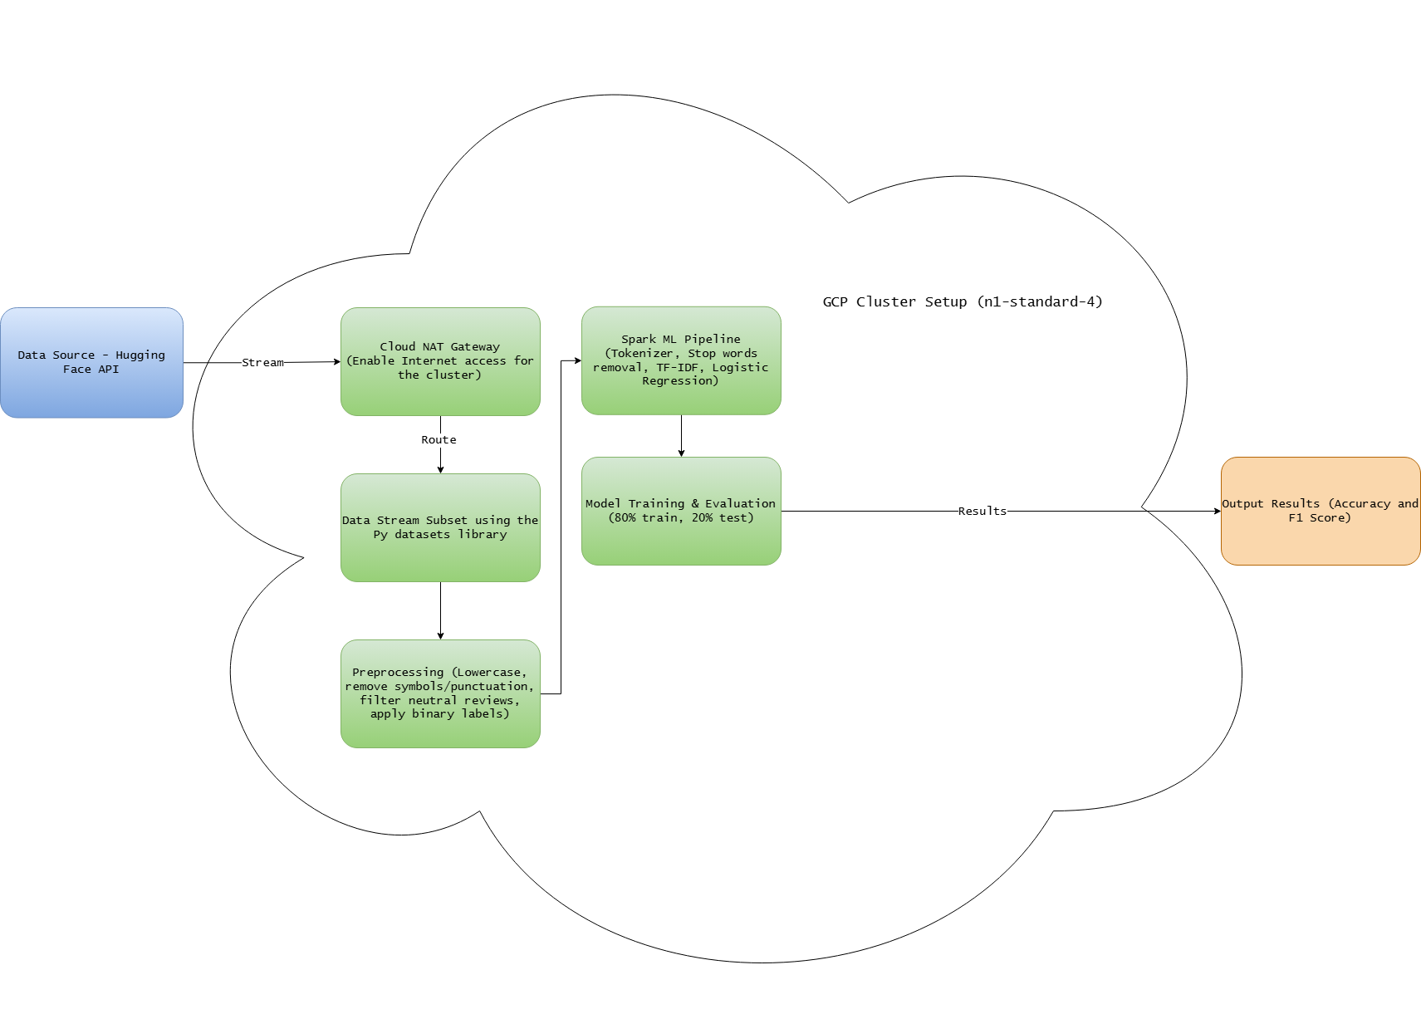

6. Experimental Setup

6.1 Cloud Infrastructure
All experiments were executed on a Google Cloud Platform (GCP) Dataproc cluster configured as a single-node instance using an n1-standard-4 machine type with 15GB of RAM. A Cloud NAT gateway was configured to provide the cluster with secure outbound internet access, enabling the pipeline to stream data directly from the Hugging Face API without requiring the dataset to be stored on the cluster. This setup reflects a lightweight, cost-conscious architecture appropriate for a proof-of-concept deployment under free-tier GCP credit constraints.

6.2 Software Environment
The pipeline was implemented in Python using Apache Spark 3.5.3 with the PySpark interface. The Spark session was initialized with 8GB of driver memory and 4GB of executor memory. The Hugging Face datasets library (version 2.19.0) was used to handle streaming data ingestion. All preprocessing, feature extraction, model training, and evaluation were performed within the distributed Spark framework using PySpark MLlib.

6.3 Pipeline Configuration
The machine learning pipeline consisted of five sequential stages. A Tokenizer split cleaned review text into individual tokens, followed by a StopWordsRemover to filter common uninformative words. HashingTF then converted the filtered tokens into numerical feature vectors using a hash space of 10,000 features, and an IDF transformer was applied to weight terms by their inverse document frequency across the corpus. Finally, a Logistic Regression classifier was trained on the resulting TF-IDF feature vectors with a maximum of 10 iterations and a regularization parameter of 0.01. An identical pipeline was constructed for the Naïve Bayes baseline model, substituting the Logistic Regression stage with a Naïve Bayes classifier using Laplace smoothing of 1.0, while keeping all preceding stages identical to ensure a fair comparison.

6.4 Evaluation Protocol
Each experiment was conducted by setting the subset size parameter and executing the full notebook from data ingestion through model evaluation. The cleaned dataset was partitioned into an 80% training set and a 20% held-out test set using a fixed random seed of 42 to ensure reproducibility across runs. Model performance was assessed using two metrics: overall accuracy and weighted F1-score, both computed on the held-out test set using PySpark's MulticlassClassificationEvaluator. Training time was recorded for each run to support scalability analysis. The full experiment was repeated across three dataset sizes (50,000, 100,000, and 250,000 records) for both the Logistic Regression and Naïve Bayes models.

7. Results and Evaluation

7.1 Class Distribution
Dataset Size | Positive | Negative
50,000 | 40,070 | 5,987
100,000 | 81,542 | 10,839
250,000 | 205,385 | 26,436
The following table presents the positive and negative review counts for each dataset size after preprocessing, illustrating the class imbalance present across all experiments.

7.2 Training & Validation Split
The following table presents the training and validation set sizes for each dataset size, reflecting the 80/20 split applied prior to model training.
Dataset Size | Training Set | Validation Set
50,000 | 37,001 | 9,056
100,000 | 73,977 | 18,404
250,000 | 185,440 | 46,381

7.3 Logistic Regression Scalability Results
Our scalability testing demonstrates the efficiency of the Spark framework across increasing dataset sizes. The following table presents results from three runs.
Dataset Size | Total Reviews | Training Time | Accuracy | F1-Score
50,000 | 46,057 | 18.71s | 91.43% | 90.78%
100,000 | 92,381 | 17.00s | 92.07% | 91.29%
250,000 | 231,821 | 31.54s | 92.82% | 92.04%

Two key observations emerge from these results. First, after an initial JVM warm-up period (which explains the faster time for the 100k run compared to 50k), training time scales predictably with dataset size. Second, model accuracy and F1-score consistently improve as the volume of training data increases, validating the big data approach. An attempt to run the model on 500,000 records encountered resource limitations on the single-node cluster, demonstrating a real-world infrastructure constraint and a clear direction for future scaling.

7.4 Naïve Bayes Baseline Results
The Naïve Bayes baseline model was evaluated under identical conditions using the same TF-IDF pipeline and train/test splits. Results are presented below.
Dataset Size | Reviews Trained On | Training Time | Accuracy | F1-Score
50,000 | 46,057 | 10.05s | 87.90% | 88.72%
100,000 | 92,381 | 14.69s | 87.93% | 88.94%
250,000 | 231,821 | 31.81s | 89.24% | 90.07%

7.5 Model Comparison
The following table presents a direct comparison of the two models at the largest dataset size (250,000 records).
Model | Dataset Size | Accuracy | F1-Score
Logistic Regression | 250,000 | 92.82% | 92.04%
Naïve Bayes | 250,000 | 89.24% | 90.07%

8. Discussion
The results of this project yield several meaningful insights into both the performance of the proposed sentiment analysis pipeline and the practical realities of distributed machine learning on cloud infrastructure.
The most notable trend across all three dataset sizes is the consistent improvement in both accuracy and F1-score as training data increases — from 91.43% and 90.78% at 50,000 records to 92.82% and 92.04% at 250,000 records respectively. This pattern directly validates the core premise of the big data approach: more data produces better models. It also aligns with findings from Aravindan et al. (2023), who similarly observed that larger training sets yielded stronger classification performance on Amazon review data using PySpark MLlib.
The training time anomaly between the 50,000 and 100,000 record runs, where the larger dataset completed faster (17.00s vs. 18.71s), can be attributed to the JVM warm-up period inherent to Apache Spark. On the first run, the JVM must initialize the runtime environment and load relevant libraries into memory, introducing overhead that is disproportionately large relative to the actual computation. Subsequent runs benefit from a pre-warmed environment, meaning the 100,000 record run began execution in a more optimal state. This is a well-documented behavior in Spark workloads and does not reflect a true scalability anomaly.
The significant class imbalance present in the dataset, approximately 87-88% positive reviews across all subset sizes. This is a known challenge in e-commerce sentiment analysis. Despite this, the model achieved over 91% accuracy and correctly classified the vast majority of reviews encountered when copying and pasting real review text into the interactive prediction module produced accurate and consistent results. This suggests that the TF-IDF feature representation, combined with Logistic Regression's regularization, was sufficient to learn a meaningful decision boundary even under imbalanced conditions. However, it is worth noting that high overall accuracy in imbalanced datasets can be partially inflated by the dominant class. Future work incorporating per-class precision and recall metrics would provide a more granular picture of how well the model handles negative reviews specifically.
A Naïve Bayes classifier was evaluated as a baseline model using the identical TF-IDF pipeline and train/test splits. The results reveal a trade-off between speed and accuracy. At smaller dataset sizes, Naïve Bayes trained considerably faster than Logistic Regression, completing in 10.05 seconds vs 18.71 seconds at 50,000 records. However, this speed advantage diminished as dataset size grew, with both models requiring nearly identical training times at 250,000 records (31.81s vs. 31.54s). On accuracy, Logistic Regression outperformed Naïve Bayes across all dataset sizes, achieving 92.82% versus 89.24% at 250,000 records. Notably, Naïve Bayes produced slightly higher F1-scores despite lower accuracy, which is likely attributable to the class imbalance. Naïve Bayes may be distributing predictions more evenly across classes while Logistic Regression is more biased toward the dominant positive class. Overall, these results confirm that Logistic Regression is the stronger choice for this task at scale, consistent with the findings of Aravindan et al. (2023).
The failure of the 500,000 record run is an instructive real-world finding rather than a shortcoming of the approach. The single-node GCP Dataproc cluster (n1-standard-4, 15GB RAM) encountered memory exhaustion when attempting to process and train on that volume of data, causing the cluster to crash. This is consistent with the fundamental motivation for distributed computing — a single-node architecture, regardless of its RAM allocation, has a hard ceiling that multi-node clusters are specifically designed to overcome. As a proof-of-concept project operating under GCP credit constraints, the single-node setup was appropriate and sufficient to demonstrate scalability trends. Deploying a multi-node Dataproc cluster in a production environment would be expected to handle the full 14.3 million review dataset without issue.
It is worth noting that upgrading the single-node cluster to 32GB of RAM may have been sufficient to process the 500,000 record subset without failure. Based on the memory consumption trends observed across the 50,000, 100,000, and 250,000 record runs, a doubling of available RAM could plausibly accommodate the roughly proportional increase in memory demand. However, this was not tested due to GCP credit constraints and remains a direction for future investigation.

9. Future Work
Several directions exist to extend this work beyond its current proof-of-concept scope. First, scaling the pipeline to a multi-node GCP Dataproc cluster would enable processing of the full 14.3 million review dataset. This would provide a more comprehensive validation of the distributed approach and potentially yield further accuracy improvements. Second, incorporating per-class precision and recall metrics would address the class imbalance issue identified in this study and offer a more nuanced evaluation of model performance on negative reviews specifically. Third, generating scalability visualizations such as plotting dataset size against training time and accuracy would have provided a more intuitive representation of the pipeline's scaling behavior for presentation purposes. Fourth, exploring more advanced feature representations such as word embeddings (Word2Vec or GloVe) in place of TF-IDF could improve the model's ability to capture semantic relationships between words. Finally, expanding the analysis to include additional Amazon product categories would test the generalizability of the approach across different review domains and sentiment distributions.

References
[1] Aqlan, A. A. Q. (2022). Data mining and revealing hidden sentiment in tweets using Spark. International Journal on Data Science and Technology, 8(1), 14–21. https://doi.org/10.11648/j.ijdst.20220801.13
[2] Aravindan, T. R., Vigneshwar, C. N., & Suganeshwari, G. (2023). Sentiment classification for Amazon fine foods reviews using PySpark. In Recent developments in electronics and communication systems (pp. 431–436). IOS Press. https://doi.org/10.3233/ATDE221293
[3] Bao, Y. (2024). A comparative study of e-commerce review sentiment analysis models based on VADER and RoBERTa. Journal of Computing and Electronic Information Management, 15(3), 115–119. https://drpress.org/ojs/index.php/jceim/article/view/28558
[4] Olalekan, S. U. (2025, August 18). Leveraging sentiment analysis for predicting Amazon product ratings. ResearchGate. https://www.researchgate.net/publication/394535525_Leveraging_Sentiment_Analysis_for_Predicting_Amazon_Product_Ratings

